# D1.2 - Traffic Jam Detection

# Related Work

Traffic fluency monitoring and jam detection is part of traffic control in all major cities and the real time information about road network fluency is of interest to all network users and traffic related authorities. Over the last years, several different methods for detecting jams have been created. In many cities traffic is monitored via road side cameras detecting fluency in the most important channels of the network and sends the image to authorities and web services. Another increasingly popular method for detecting jams is by traffic message channels (TMC) that collect information about road network status from roadside sensors and vehicles and transmits the information via radio signals to the end user. TMC information is most commonly used in navigators, both on inbuilt vehicle navigating systems and separate navigator devices. [1]

Over the past few years also different smartphone applications, such as Waze or Inrix have emerged on the market. In these applications information gathering is commonly done either with the vehicles connected to the system or by the users who report their journey conditions around them. Different applications provide different type of information, usually including one or several of the following information types: jams, weather, road work and accidents.

What is common to all known methods for detecting jams, no service is provided specifically to the public transport users as most services are targeted for private vehicle drivers and the authorities. Based on our surveys no service is being used specifically to public transport nor uses the delay information of public transport vehicles, which makes the traffic jam detection module an unique tool.

# Component Description

The jam detection module frequently polls vehicle location compared to the scheduled location from the Helsinki public transport service. The module analyses the vehicle situation and detects where there are traffic jams in the certain transportation authority’s transportation area. The interface returns always the current jam situation, so client does not need to keep the jams in memory.

The module detects the jams based the tram location, taking into notice the delay and how fast it increases. Also, the jam is only detected if there are several vehicles filling the same criteria within the same area.

The module provides information about the nearest stop to the detected jam and also the previous stop from where the affected vehicles have come from. Based on this information current traffic situation is visualized on the application. All of Helsinki city tram network can be drawn on the map, but only lines that are currently affected by trams are shown on the map at each time. If no jams are detected in between two stops, this interval is shown with green colored line. If a jam is detected between stops, the interval is shown with red colored line. Image x shows a screenshot of the application on how the jams are presented in Helsinki city center during the trial.

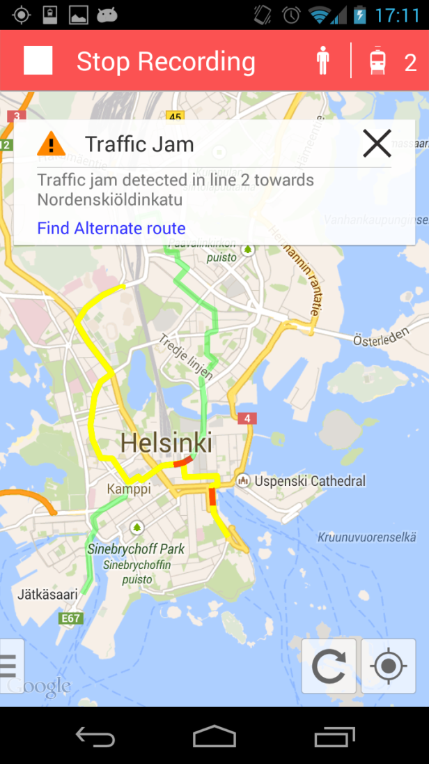

Image x. visualization of the current traffic situation in Helsinki based on Jam detection

## Module overall architecture

The JamDetector module simplified architecture is visualized in the Figure x. The public transportation systems generally differ in each city or area in multiple ways in the available data and data formats. The different public transportation systems are isolated in the module and configurable using the Spring Framework.



Figure x Traffic Jam Module Architecture

|  |  |
| --- | --- |
| **Address** | 213.157.92.101:80 |
| **Path** | /jamdetector/JamService.svc/jams/{authority} |
| **Protocol** | HTTP GET |
| **Data format** | JSON |

Table 1. Module details

## Live+Gov SaaS solution compatibility

The JamDetector follows Live+Gov SaaS architecture. This means that all connecting clients are authorized. Also the JamDetector provides the heart beat (health check) information to the SaaS service and sends the application log to the service.

## API description

The API lists the jams detected in the certain public transportation area in JSON format. The jam object contains information about the vehicles participating the detected jam and vehicle’s nearest stop/station. This information can be used to visualize the jam location for the users.

## Data structure

The data structure of the JSON-message is described in figure x.



Figure x JSON data structure

Example of a given message:

/jamdetector/JamService.svc/jams/hsl

[ { "Id" : 0,

"IsJam" : true,

"SlowVehicles" : [ { "CumulativeDelay" : 13,

"NextStop" : { "Code" : "1301453",

"Latitude" : 60.197929999999999,

"Longitude" : 24.876580000000001,

"Name" : "Laajalahden aukio"

},

"PreviousStop" : { "Code" : "1301455",

"Latitude" : 60.195390000000003,

"Longitude" : 24.873429999999999,

"Name" : "Tiilimäki"

},

"Stop" : { "Code" : "1301455",

"Latitude" : 60.195390000000003,

"Longitude" : 24.873429999999999,

"Name" : "Tiilimäki"

},

"Vehicle" : { "Delay" : 13,

"Id" : "RHKL00076",

"IsOnStop" : false,

"Latitude" : 24.873405999999999,

"LineDirection" : 2,

"LineId" : "1004",

"Longitude" : 60.195535999999997,

"NextStopIndex" : 2,

"Time" : "20140116-102700",

"Timestamp" : "/Date(1389860820413+0200)/"

}

},

{ "CumulativeDelay" : 72,

"NextStop" : { "Code" : "1240419",

"Latitude" : 60.203020000000002,

"Longitude" : 24.96584,

"Name" : "Kyläsaarenkatu"

},

"PreviousStop" : { "Code" : "1230410",

"Latitude" : 60.204529999999998,

"Longitude" : 24.96998,

"Name" : "Toukoniitty"

},

"Stop" : { "Code" : "1230410",

"Latitude" : 60.204529999999998,

"Longitude" : 24.96998,

"Name" : "Toukoniitty"

},

"Vehicle" : { "Delay" : 82,

"Id" : "RHKL00065",

"IsOnStop" : false,

"Latitude" : 24.968769999999999,

"LineDirection" : 2,

"LineId" : "1006",

"Longitude" : 60.203980999999999,

"NextStopIndex" : 3,

"Time" : "20140116-102700",

"Timestamp" : "/Date(1389860820405+0200)/"

}

}

],

"SlowVehiclesInJamCount" : 2

} ]

]

In this example the JamDetector has detected one jam and there are two vehicles in the jam. In addition to the vehicle information the next, previous and nearest stop information is returned. The jam location can be approximated either from the participating vehicle locations or stop locations.

The interface contains more information than the current clients require. This is for debugging and possible visualization purposes. For example vehicle’s line information is such information.

If there are no jams currently detected, the interface returns:

[]

1. Evaluation

The module development begun with evaluating different methods for creating the detection algorithms and creating a way to detect jams reliably. The tram location data from Helsinki provides reliable information about the delay of a vehicle in real time and was considered the most efficient and reliable source of data for the jam detection.

A comprehensive and reliable detection algorithm was created through experimenting in the early stages of the module development. The parameters to be used were searched the most suitable values through thorough consideration in order to generate reasonable and accurate alerts that would correspond with the logical situation in traffic and would fit in the definition of a jam. After some weeks of monitoring the detections, the defined values were also re-evaluated and re-defined before the first pilot based on the previous observations.

Based on the first trial results, the amount of detected jams is seen relatively high, on average 3 jams were received on each time the API was called. This would indicate the parameters needing to be set tighter in the future if only greater jams are wanted to be detected. When evaluating the accuracy it was quickly discovered that validating the detection is rather challenging when not having the possibility to verify the situation on site. User questionnaires showed that no users were travelling in the areas where alerts were given at the time of the alert and therefore they could not reliably state their opinion about the accuracy of alerts. Also, no known major jams took place during the trial in the pilot area and therefore manual validation could not be done during the trial. Manual comparison to other known services providing jam alerts was done. In all cases the detected jams were of a short duration, mainly less than a minute and therefore no reliable statement about accuracy could be done at this stage. In the comparison we used two popular services: Waze [2], which is a mobile application providing traffic data in over 30 countries and V-traffic [3], a national service in Finland for providing traffic data in major cities. Based on the comparison to other services the results seem promising as alerts were given in the same areas at the same time, only with minor differences.

When comparing the module to existing services it is obvious that there are existing systems that provide information with more geographical coverage and collect the data from greater number of sources. Thus, these services also provide more alerts as they also cover roads that are not included in the current module coverage, the Helsinki tram network. What needs to be addressed when comparing the module to existing services is that the other services do not focus on public transport and using only these services would not help to meet the requirements of the mobility use case in full. However, the possibility to support the jam detection module with existing services needs to be further studied.

We believe that when expanding the data to also cover other public transport vehicles, the coverage in the module will increase and the quality and the usefulness of the module improves. For example in the Helsinki region, all public transport busses, trams, trains and the ferry will be covered in the new public transport information system to be implemented in 2016. Then the module will provide a much better service with greater geographical coverage and expanded fleet. Unfortunately at the time of development, location data is not yet available for other vehicles than trams but the possibility to include these vehicles in the jam detection has been taken into notice from the start.

As no reliable evaluation is possible at this stage we will continue validating the module, analyzing the results and developing the algorithms. This process will continue until the final trial where improvements and reliable accuracy of the module are hoped to have been achieved.

## References:

[1] http://www.tisa.org/technologies/tmc/

[2] http://www.inrixtraffic.com/

[3] http://www.v-traffic.fi/